Energy Globe Foundation GmbH

Hessenberg 14, 4814 Neukirchen, Austria

Email: contact@energyglobe.info

Website: www.energyglobe.info/participation

 |  |  | 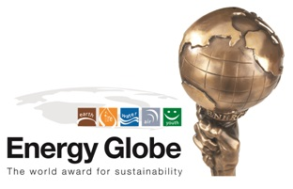

Project Submission Checklist
PART I - GENERAL CONTACT INFORMATION

1.1 CONTACT DETAILS OF ORGANIZATION
(only relevant if submitted by an institution/company/organization - individuals please complete 1.2)

Full Name of institution/ company/organization:

Street and street number:
Postal code: |  | Town:
Country: |  | Official homepage:
Telephone:  (including country code; no brackets or slashes) |  | Official company email:  (i.e. info@examplecompany.com)

1.2 INDIVIDUAL CONTACT DETAILS
Given name: |  | Family name:
Academic title: |  | Gender: (please mark with x) |  | ( ) Male / ( ) Female

Street and street number:
Postal code: |  | Town:
Country: |  | Email (of contact person):
Telephone:  (including country code; no brackets or slashes) |  | Mobile Phone:  (including country code; no brackets or slashes)
PART II - PROJECT INFORMATION – OVERVIEW

2.1 GENERAL INFORMATION

Project title:
Category:  (please mark with x, choose only one category) | ( ) Earth ( ) Fire ( ) Water ( ) Air ( ) Youth ( ) Sustainable Plastics | Status of implementation:  (please mark with x) |  | ( ) Planned  ( ) Implemented project or ongoing project
Country of implementation:  (choose only one) |  | Optional: additional countries of implementation:

2.2 PROJECT SUMMARY
Please summarize (~10-15 lines,) what the project is about and what major outcomes have been achieved (please state concrete figures), especially any relevancy in regard to environmental protection, improvement of living and/or economic conditions, awareness creation, emission reduction, renewable energy, energy and resource efficiency, counteracting climate change, etc.; Please use a formal writing style as this summary will be published in our online database (use your/your organization’s name in the text and do not use expressions like We, I, our company, etc.).
PART III – DETAILED PROJECT INFORMATION
Please provide a complete and proper description at the jury’s request.

A) Initial Situation and Context of the Project/Initiative
Please provide information (max half a page, 2000 characters) on the initial situation (problems, challenges) before the project was implemented. Depending on the type of project, please include the environmental, ecological, economic, social, energy or other relevant context of your country.

B) DESCRIPTION OF PROJECT Objective and Motivation
What was your overall motivation to start this project and what have been the project’s objectives? (max half a page, 2000 characters)

C) Scope and Implementation Activities
Please describe in more detail (max half a page, 2000 characters) the scope of the project and the major activities that have been conducted for its implementation.

D) INNOVATION
Please describe the innovative aspects of your project under consideration of the technological standards and conditions (i.e. regional conditions, social conditions, economic conditions or political situation) of your country (max half a page, 2000 characters).

E) Implementation and Costs

- For projects including a technological component: Please describe the technology applied, as well as the costs and economic benefits (max half a page).

- For projects including a social component: Please describe the approach that you have chosen as well as the social impact of your measures had on which target groups. (max half a page, 2000 characters).

F) Description of achieved Results
Please describe in detail all direct and indirect results. Depending on your project, please focus especially on environmental and/or social and/or economic impacts resulting from the implementation of your initiative. Where possible, please include figures (i.e. number of people trained or jobs created, tons of CO² avoided, m³ of water treated, MWh of renewable energy provided, energy efficiency before/after renovation, tons of waste collected/reduced, number of trees planted, etc.) or descriptions on how people or environment have otherwise benefitted from your project (max half a page, 2000 characters).

G) Replication Potential (MODEL CHARACTER)
Please describe the replication potential of your project in other regions or countries (max half a page, 2000 characters).

PART IV – PHOTOS AND PROJECT DOCUMENTATION
Please send 4-6 photos in print quality (~400 kb – 3 MB per picture) which document your project well. Preferred file format .jpg or .gif
You can also upload additional project material.
Upload these materials as part of your online-submission on www.energyglobe.info/participation/

PART V – FINAL INFORMATION AND AGREEMENTS

5.1 HOW DID YOU HEAR ABOUT THE ENERGY GLOBE AWARD?
Please mark all answers that apply with x.

( ) Mail by Energy Globe ( ) Print media ( ) Friends/Colleagues
( ) Call by Energy Globe ( ) Facebook ( ) Google

( ) Internet ( ) Radio/TV ( ) Conferences/Fairs
( ) Contact by Energy Globe Ambassador ( ) Other

5.2 SUPPORT BY ENERGY GLOBE PARTNER

In the future there is a possibility that selected projects with exceptional prospects are supported by an ENERGY GLOBE Partner on their way towards marketability with management, sales and distribution know-how, as well as financially. If you are interested in this possibility, please mark the yes field with x.

( ) Yes / ( ) No
5.3 STATEMENT OF AGREEMENT (ACCEPTANCE IS OBLIGATORY for submission)
By participation in the ENERGY GLOBE Award competition I agree to the electronic processing, sharing within the ENERGY GLOBE partner network and publication of my project.
I herewith declare, that my statements regarding the submitted project are complete and correct and may in part or in total be published by Energy Globe. Energy Globe shall not be liable for the correctness and completeness of these statements. In case of any law suits or litigation, e.g. regarding copyright or publishing right, the submitter is responsible that Energy Globe shall not be involved in any such law suits or litigations. The submitter shall in any case completely indemnify Energy Globe against all effects resulting from such law suits or litigations. By marking the yes field with x, I confirm agreement with this declaration and the resulting legal consequences (Acceptance is required for submission). Please mark the corresponding field with x.

( ) Yes / ( ) No

Thank you for completing the required information.

We kindly ask you to submit your project information online on www.energyglobe.info/participation/

For organizational reasons please do not send this file via email. You can simply copy/paste the entered information with
Ctrl-C/Ctrl-V into the online form. Thank you for your support.

After submitting your project online, please check whether we have received it successfully!

- Fill in all required texts and upload all documents and click at the “Submit application”- Button. (Please see screenshot below)
We do not receive your texts and documents until you click on this button.

- Check your Email-Inbox if you have received an email-confirmation at the email address provided. (also check your Spamfile).
Subject of this email: Your project application has been successfully received (ID: AWD0000)

- Email us at contact@energyglobe.info in case you do not receive the confirmation email.

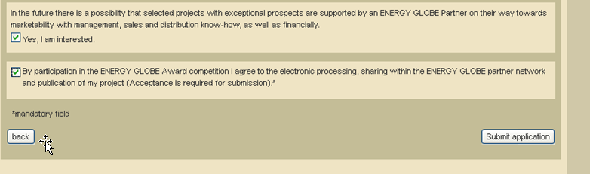

Categories:

EARTH:

Projects relating to agriculture, crops employable for energy, building materials, insulation, solar energy and overall energy efficient construction

FIRE:

Projects relating to energy production, the efficient and sustainable use of energy in all fields of application

WATER:

Projects relating to the use and processing of drinking water, waste water management as well as the preservation of water reserves

AIR:

Projects relating to air pollution management – indoor and outdoor – improving air quality, overall climate protection and the reduction of CO2

YOUTH:

All sustainable projects to or implemented in conjunction with young people to improve environmental awareness

Special category on the issue "smart plastics":
All projects that ensure a sustainable use of plastic

